

Centre Name: ACE-HCMC-2-FPT (VN.033)

Address: 590 Cách Mạng Tháng 8 Street, District 3, Ho Chi Minh City, Viet Nam



WEB PHOTO

SHARE

Design Document

|  |  |  |  |
| --- | --- | --- | --- |
| **Faculty:** | | **Mr. Nguyen Ngo Phuoc** |  |
| **Batch No:** | | **F2-10-1203-T0** |  |
| **Group No:** | | **01** |  |
| **Student** |  | **Full Name** | **Roll No.** |
|  | 1. | NGUYEN VU HUNG | STUDENT636555 |
|  | 2. | TRAN VAN HAI | STUDENT630717 |
|  | 3. | LE NGOC NHUT | STUDENT636217 |
|  | 4. | NGUYEN ANH TUAN | STUDENT576665 |

September 2013

# Table of Contents

Table of Contents 2

I. Acknowledgment 7

II. Problem Definition 8

1. Introduction 8

2. Existing Scenario 8

III. Customer Requirement Specification 9

IV. Functional Requirements Specification 11

1. Website 11

2. Registered User 12

3. Administrator 13

V. Hardware / Software Requirements 14

1. Hardware Requirements 14

2. Software Requirements 14

VI. Development Software 15

VII. Technology 16

VIII. Task sheet review 1 17

I. Architecture & Design of the Project 19

1. Presentation Tier: 20

2. Business Logic Tier: 20

3. Data Access Tier: 20

II. Algorithms - Data Flowchart 21

1. Login process 21

2. Logout process 22

3. Insert process 23

4. Update process 24

5. Delete process 25

6. Search process 26

III. Use Case Diagram 27

1. Visitor 27

2. User 28

3. Admin 29

IV. Sequence Diagram 30

1. Visitor - Login 30

2. User - Logout 32

3. Visitor - Registration 33

4. User - Insert Image 35

5. User - Update Image 37

6. User - Delete Image 39

7. Search 41

8. User - Feedback 43

9. Contact 45

10. User - User Profile 47

11. Administrator - Send Feedback 49

12. Administrator - Create Collection 51

13. Administrator - Create FAQs 53

14. Administrator - Answer Feedback 55

V. Entity–Relationship Design 57

1. Entity–Relationship Diagram 57

2. Entities and Properties 58

2.1. Table admin 58

2.2. Table contact 58

2.3. Table faqs 58

2.4. Table feedbacks 59

2.5. Table collections 59

2.6. Table users 59

2.7. Table images 60

2.8. Table comments 60

2.9. Table user_friends 61

VI. Task sheet review 2 62

I. Database Design 64

1. Database Relationship Diagram (DRD) 64

2. Database Structure 65

2.1. Table: admin 65

2.2. Table: contact 65

2.3. Table: faqs 65

2.4. Table: feedbacks 65

2.5. Table: collections 66

2.6. Table: users 66

2.7. Table: images 66

2.8. Table: comments 67

2.9. Table user_friends 67

3. Database Constrains 68

3.1. Table: users 68

3.2. Table: feedbacks 68

3.3. Table: images 68

3.4. Table: comments 68

3.5. Table: user_friends 69

II. GUI Designs – Front-End 70

1. Homepage 70

2. Login 71

3. Sign Up 72

4. Homepage 73

5. User Comments 74

6. User Friends 75

7. User Profile Change Password 76

8. User Upload Image 77

9. View Image 78

10. View Menu 79

11. Page About Us 80

12. Page Contact 81

13. Page FAQs 82

14. Page Feedback 83

15. Page Term and Privacy 84

III. GUI Design – Back-End 85

1. Login 85

2. Administrator Dashboard 86

3. User Manage 87

4. User Manage Declined 88

5. User Manage Edit User 89

6. User Manage Validating 90

7. Collection Manage 91

8. Image Manage 92

9. Image Manage Edit 93

10. FAQs Manage 94

11. Contact Manage 95

12. Contact Manage Reply 96

IV. Sitemap 97

1. Front-End Sitemap 97

2. Back-End Sitemap 98

V. Task sheet review 3 99

REVIEW I

# Acknowledgment

We would like to acknowledge all those who have given support and help us make the project a success.

We wish to express our deep gratitude to all teachers who have been devoting their lives to teach us how to stand-alone and walk ahead.

We are grateful to our families who take care and encourage us even though we are successful or failed, also to our friends who are always care of us. They never leave us alone and always look forward to us when we are on any road of the life.

We are much thankful to the entire staff and chairpersons at the Head Office of Aptech Worldwide, Aptech – Vietnam, and FPT – Aptech Centre who have been organizing and looking after our studying course.

There are no words to show our appreciation for teachers of FPT Aptech Centre who have been organizing and looking after us during our studying course to finish this project. Our special thanks not only Mr Nguyen Ngo Phuoc who works day by day to teach and guide us in our travel to discover the wonder of Java Programming Language but also mentors in e-Project Team at the Head Office who instruct and help us.

Finally, we would like to offer many thanks to all our schoolfellows for their valuable suggestions.

We would like to thank sincerely!

Group 1 – FPT Aptech.

# Problem Definition

## Introduction

Our client has a passion of collecting various kinds of pictures. He is having a large collection of photographs of nature, sceneries, miscellaneous ones, and the wild animal s photographs, etc. He now wants to share his collection with everyone. And so he has approached us for building the site for him, where the picture files can be uploaded, and viewed on the site (i.e., downloaded from the site). He also wants the users of the website to be able to upload the file, thereby providing the facility of sharing the pictures of sceneries, miscellaneous pictures, etc. with the help of the site.

So he has approached us for helping him by building a website through which the pictures can be uploaded over the site.

## Existing Scenario

The website system allows visitor sign up for an account. After approved by Administrator, registered users can upload up to maximum of 35 images over the site and share their own uploaded images. Images could be able to share by these following methods:

* Share with Friends: Friends of user can view and place comments on shared images
* Share to Public: Non-registered/visitors can view shared images
* Share to Social Network: Images can be share to Social network like: Facebook, Twitter…

# Customer Requirement Specification

The customer wants the following tasks to be implemented in the website.

1. The menu of the website should include the following.
   * Home Page
   * Login Page or Register Page
     1. Upload the picture files
     2. View the picture files
     3. Delete the picture files (the user can only delete the files which are uploaded by him)
   * About the Site
   * Feedback
   * FAQ s
   * Contact Information
2. On the home page the following details are to be displayed.

* The details of the new pictures that are uploaded
* The details of the new users of the website (like how many have registered with the site today)
* The details of the total number of users (total number of registered users of the site)

1. The user after registering with the site will only be able to access the site once approved by the administrator.
2. The administrator once approves, a mail is to be sent to the user’s mail id automatically indicating that the registration is accepted. And if the registration is declined, then also the mail is to be sent automatically to the users email id, stating that the registration is declined.
3. The administrator (the site owner will have the right to cancel or allow the user, once they are registered)
4. Only the registered users should be able to upload the file or view the file. i.e., the registered users will only be able to share the file.
5. Once the user logs into the site, the following menu should appear

* Home Page
* User Profile (Here the profile of the user is to be displayed. In this page itself the user should be able to edit the profile).
* View the picture files
* Upload a picture file
* The picture files uploaded by me (here only the picture files uploaded by this user will be visible). In this link itself the user should be able to update or re-upload the file, and also should be able to delete the file
* About the Site
* Feedback
* FAQ s
* Contact Information

1. On the upload link page, the following details are to be included

* The name of the picture file
* The description of the picture file
* Link for uploading the file

1. Each registered user should only be able to upload up to a maximum of 35 images. If this limit is crossed, then it should give an error message stating that the user should delete one of the files to upload a new one.
2. On the Feedback page, the users of the site should be able to post their feedback or their queries. The queries thus posted will then be answered by the administrator (site owner).
3. The FAQ s Page will have the following questions, along with their answers.

* How to view the image files?
* How to register with the site?
* How to download the picture file?
* How to upload the picture file?
* How to post a Query?
* Is there any limitation in uploading files?

The administrator will have the right to answer the query, view or edit or delete the FAQ’s.

# Functional Requirements Specification

## Website

* The menu of the website should include the following.
  + Home Page
  + Login Page or Register Page
  + About the Site
  + Feedback
  + FAQ s
  + Contact Information
* On the home page the following details are to be displayed.
  + The details of the new pictures that are uploaded
  + The details of the new users of the website (like how many have registered with the site today)
  + The details of the total number of users (total number of registered users of the site)
* The FAQ s Page will have the following questions, along with their answers.
  + How to view the image files?
  + How to register with the site?
  + How to download the picture file?
  + How to upload the picture file?
  + How to post a Query?
  + Is there any limitation in uploading files?

## Registered User

* The user after registering with the site will only be able to access the site once approved by the administrator.
* Only the registered users should be able to upload the file or view the file. i.e., the registered users will only be able to share the file.
* Once the user logs into the site, the following menu should appear
  + Home Page
  + User Profile (Here the profile of the user is to be displayed. In this page itself the user should be able to edit the profile).
  + View the picture files
  + Upload a picture file
  + The picture files uploaded by me (here only the picture files uploaded by this user will be visible). In this link itself the user should be able to update or re-upload the file, and also should be able to delete the file
  + About the Site
  + Feedback
  + FAQ s
  + Contact Information
* On the upload link page, the following details are to be included
  + The name of the picture file
  + The description of the picture file
  + Link for uploading the file
* Each registered user should only be able to upload up to a maximum of 35 images. If this limit is crossed, then it should give an error message stating that the user should delete one of the files to upload a new one
* On the Feedback page, the users of the site should be able to post their feedback or their queries.

## Administrator

* Administrator will have ability of managing (include create new / edit / delete):
  + Collections
  + FAQs
  + Contact information with option to answer
  + Uploaded images by users
* Manage user registration:
  + The administrator once approves, a mail is to be sent to the user’s mail id automatically indicating that the registration is accepted. And if the registration is declined, then also the mail is to be sent automatically to the users email id, stating that the registration is declined.
  + The administrator (the site owner will have the right to cancel or allow the user, once they are registered)
* Manage Feedback:
  + The queries thus posted will then be answered by the administrator (site owner)

# Hardware / Software Requirements

## Hardware Requirements

|  |  |
| --- | --- |
| **Component** | **Requirement** |
| Server | Processor type:  Pentium III-compatible processor or faster  Processor speed:  Recommended: 2.0 GHz or faster |
| OS | Microsoft Windows Server 2003 or higher |
| Memory (RAM) | RAM:  Minimum: 512 MB  Recommended: 2.048 GB or more  Maximum: Operating system maximum |
| Hard Drive | Free space:  Minimum: 50 MB  Recommended: 50 GB or more  Maximum: Operating system maximum |

## Software Requirements

|  |  |
| --- | --- |
| **Component** | **Requirement** |
| JDK | Java Development Kit 7 |
| J2EE | Java 2 Platform, Enterprise Edition 7 |
| IDE | NetBeans IDE 7.3.1 |
| RDBMS | Microsoft SQL Server 2008 |

# Development Software

|  |  |
| --- | --- |
| **Component** | **Requirement** |
| JDK | Java Development Kit 7 |
| J2EE | Java 2 Platform, Enterprise Edition 7 |
| IDE | NetBeans IDE 7.3.1 |
| RDBMS | Microsoft SQL Server 2008 |
| Design tool | Adobe Photoshop CS 6 |
| HTML Editor | Adobe Dreamweaver CS6 |
| SVN | TortoiseSVN 1.8 |
| Application server | GlassFish Server Open Source Edition 4.0 |

# Technology

* HTML 5 & CSS 3.0
* jQuery JavaScript library
* AJAX development techniques
* Model–view–controller (MVC) software architecture pattern
* commons-fileupload-1.3
* commons-io-2.4
* Enterprise JavaBeans (EJB)
* Java 2 Platform, Enterprise Edition 7
* Java Development Kit 7
* Java Servlet programming language class
* Java Database Connectivity

# Task sheet review 1

|  |  |  |  |  |  |
| --- | --- | --- | --- | --- | --- |
| Project Title: Web Photo Share | | Project Ref. No: 1 | | | |
|  |  | Date of Preparation of Activity Plan | | | |
| No. | Task | Start Date | Actual Days | Member Names | Status |
| 01 | Acknowledgment | September 23, 2013 | 3 | All Members | Completed |
| 02 | Problem Definition | Completed |
| 03 | Customer Requirement | Completed |
| 04 | Function Requirement | Completed |
| 05 | Hardware/Software | Completed |
| 06 | Development Software | Completed |
| 07 | Technology | Completed |
| 08 | Task sheet | Completed |

|  |  |  |
| --- | --- | --- |
|  | Prepare By: Group 1 | Approved By: Faculty |
| Date: Sep 26, 2013 | **Team Leader**  **Nguyen Vu Hung** | **Nguyen Ngo Phuoc** |

REVIEW II

# Architecture & Design of the Project



*Three-Tier Architecture of the Project*

## Presentation Tier:

Is the tier in which the users interact with an application. Presentation Tier contents Shared UI code, Code Behind and Designers used to represent information to user.

Technology:, HTML 5 & CSS 3.0, jQuery JavaScript library, AJAX development techniques,

## Business Logic Tier:

Is mainly working as the bridge between Data Tier and Presentation Tier. All the Data passes through the Business Tier before passing to the Presentation Tier.

Technology: OOP, Java Servlet programming language class

## Data Access Tier:

Is basically the server which stores all the application’s data. Data tier contents Database Tables, Database Views and other means of storing Application Data.

Technology: SQL Server, Java Database Connectivity

# Algorithms - Data Flowchart

Symbol generates:



## Login process



## Logout process



## Insert process



## Update process



## Delete process



## Search process



# Use Case Diagram

## Visitor



## User



## Admin



# Sequence Diagram

## Visitor - Login



|  |  |  |
| --- | --- | --- |
| Use Case Name | Login | |
| Author | Tran Van Hai | |
| Actors | Administrator , visitor | |
| Description | Actors use this use case to login to system | |
| Requirements |  | |
| Pre-Conditions |  | |
| Post-Condition |  | |
| Basic Flow | Actors action  1. Actors click on “Login “ button  3. Actors enter username and password into form.  4. Actors click “Login”  button  [alternative] | System Response  2. The system display ”Login” page the following control:  - “Username” text field  - “Password” text field  - “Login” button  - “Cancel” button  5. The system validate Username and Password  6. The system log Actors into system. |
| Alternative Flow | Actors action  [alternative] Actors click Cancel button | System Response  System return to Homepage |
| Exceptions | Actors action  [exception1] Actors provide invalid Username and Password | System Response  1. System display message: “The username or password provided are incorrect” |

## User - Logout



|  |  |  |
| --- | --- | --- |
| Use Case Name | Logout | |
| Author | Tran Van Hai | |
| Actors | Administrator, User | |
| Description | Actors use this use case to login to system | |
| Requirements |  | |
| Pre-Conditions | Already login into the System | |
| Post-Condition |  | |
| Basic Flow | Actors action  1. Actors click on “Logout “ button  3. Actors click “OK” button  [alternative] | System Response  2. System display message: “Do you want to logout?”  5. System logout Actors. |
| Alternative Flow | Actors action  [alternative] Actors click Cancel button | System Response  System return to previous page |
| Exceptions |  |  |

## Visitor - Registration



|  |  |  |
| --- | --- | --- |
| Use Case Name | Student Registration | |
| Author | Tran Van Hai | |
| Actors | Student | |
| Description |  | |
| Requirements |  | |
| Pre-Conditions | Actors has UNIQUEID | |
| Post-Condition |  | |
| Basic Flow | Actors action  1. Actors click on “User Registration “ button  3. Actors click “Submit”  button  [alternative] | System Response  2.System display Registration page the following input profile User and input optional User  4. Validate form [exception1]  5. System save database |
| Alternative Flow | Actors action  [alternative] Actors click Cancel button | System Response  System return to previous page |
| Exceptions | Actors action  [exception1] Actors provide invalid User Registration | System Response  1. System display message: “error message” |

## User - Insert Image



|  |  |  |
| --- | --- | --- |
| Use Case Name | Insert | |
| Author | Tran Van Hai | |
| Actors | Administrator, User | |
| Description | Actors use this use case to insert new information into system | |
| Requirements |  | |
| Pre-Conditions | Already logged in to the System as Administrator or User | |
| Post-Condition | Success: New information is saved into system database  Fail: Refill information | |
| Basic Flow | Actors action  1. Actors click on “Insert image” button  3. Actors enter new information into required fields.  4. Actors click “Submit”  button  [alternative1] | System Response  2. System displays ”Insert image” page  5. System validates new information  [exception1]  6. System saves new information into Database. |
| Alternative Flow | Actors action  [alternative1] Actors click “Cancel” button | System Response  System returns to previous page |
| Exceptions | Actors action  [exception1] Actors provide invalid information | System Response  1. System displays error message |

## User - Update Image



|  |  |  |
| --- | --- | --- |
| Use Case Name | Update | |
| Author | Tran Van Hai | |
| Actors | Administrator, User | |
| Description | Actors use this use case to insert new information into system | |
| Requirements |  | |
| Pre-Conditions | Already logged in to the System as Administrator or User | |
| Post-Condition | Success: New information is saved into system database  Fail: Refill information | |
| Basic Flow | Actors action  1. Actors click on “update image” button  3. Actors enter update information into required fields.  4. Actors click “Submit”  button  [alternative1] | System Response  2. System displays ”update image” page  5. System validates update information  [exception1]  6. System saves new information into Database. |
| Alternative Flow | Actors action  [alternative1] Actors click “Cancel” button | System Response  System returns to previous page |
| Exceptions | Actors action  [exception1] Actors provide invalid information | System Response  1. System displays error message |

## User - Delete Image



|  |  |  |
| --- | --- | --- |
| Use Case Name | Delete | |
| Author | Tran Van Hai | |
| Actors | Administrator, User | |
| Description | Actors use this use case to delete information from system | |
| Requirements |  | |
| Pre-Conditions | Already logged in to the system | |
| Post-Condition | Success: Selected information is deleted from system database  Fail: Refill information | |
| Basic Flow | Actors action  1. Actors click on “Delete” button  4. Actors click “Yes” button  [alternative] | System Response  2. System displays “Delete Confirm” page  5. The system deletes the selected information  [exception1] |
| Alternative Flow | Actors action  [alternative] Actors click Cancel button | System Response  System returns to previous page |
| Exceptions | Actors action  [exception1] Actors provide invalid information | System Response  1. System displays error message |

## Search



|  |  |  |
| --- | --- | --- |
| Use Case Name | Search | |
| Author | Tran Van Hai | |
| Actors | Administrator, User, Visitor | |
| Description | Actors use this use case to information into system | |
| Requirements |  | |
| Pre-Conditions | Already logged in to the system | |
| Post-Condition | Success: Found information is displayed on the “Display” page  Fail: Refill information | |
| Basic Flow | Actors action  1. Actors input search keyword into Keyword Text Field  2. Actors click on “Search“ button | System Response  3. System validate keywords  [exception1]  4. System display ”Search Result” page |
| Alternative Flow |  |  |
| Exceptions | Actors action  [exception1] Actors provide invalid keywords | System Response  1. System display error message |

## User - Feedback



|  |  |  |
| --- | --- | --- |
| Use Case Name | FeedBack | |
| Author | Tran Van Hai | |
| Actors | User | |
| Description | Actors use this use case to insert new information into system | |
| Requirements |  | |
| Pre-Conditions | Already logged in to the System as Administrator or User | |
| Post-Condition | Success: New information is saved into system database  Fail: Refill information | |
| Basic Flow | Actors action  1. Actors click on “Feedback” button  3. Actors enter new information into required fields.  4. Actors click “Submit”  button  [alternative1] | System Response  2. System displays ”Feedback” page  5. System validates new information  [exception1]  6. System saves new information into Database. |
| Alternative Flow | Actors action  [alternative1] Actors click “Cancel” button | System Response  System returns to previous page |
| Exceptions | Actors action  [exception1] Actors provide invalid information | System Response  1. System displays error message |

## Contact



|  |  |  |
| --- | --- | --- |
| Use Case Name | Contact | |
| Author | Tran Van Hai | |
| Actors | Visitor | |
| Description | Actors use this use case to insert new information into system | |
| Requirements |  | |
| Pre-Conditions | Already logged in to the System as Administrator or User | |
| Post-Condition | Success: New information is saved into system database  Fail: Refill information | |
| Basic Flow | Actors action  1. Actors click on “Feedback” button  3. Actors enter new information into required fields.  4. Actors click “Submit”  button  [alternative1] | System Response  2. System displays ”Feedback” page  5. System validates new information  [exception1]  6. System saves new information into Database. |
| Alternative Flow | Actors action  [alternative1] Actors click “Cancel” button | System Response  System returns to previous page |
| Exceptions | Actors action  [exception1] Actors provide invalid information | System Response  1. System displays error message |

## User - User Profile



|  |  |  |
| --- | --- | --- |
| Use Case Name | User Profile | |
| Author | Tran Van Hai | |
| Actors | User | |
| Description | Actors use this use case to insert new information into system | |
| Requirements |  | |
| Pre-Conditions | Already logged in to the System as Administrator or User | |
| Post-Condition | Success: New information is saved into system database  Fail: Refill information | |
| Basic Flow | Actors action  1. Actors click on “User Profile ” button  3. Actors enter new information into required fields.  4. Actors click “Submit”  button  [alternative1] | System Response  2. System displays ” User Profile” page  5. System validates new information  [exception1]  6. System saves new information into Database. |
| Alternative Flow | Actors action  [alternative1] Actors click “Cancel” button | System Response  System returns to previous page |
| Exceptions | Actors action  [exception1] Actors provide invalid information | System Response  1. System displays error message |

## Administrator - Send Feedback



|  |  |  |
| --- | --- | --- |
| Use Case Name | Send Feedback | |
| Author | Tran Van Hai | |
| Actors | User | |
| Description | Actors use this use case to insert new information into system | |
| Requirements |  | |
| Pre-Conditions | Already logged in to the System as Administrator or User | |
| Post-Condition | Success: New information is saved into system database  Fail: Refill information | |
| Basic Flow | Actors action  1. Actors click on “Send Feedback” button  3. Actors enter new information into required fields.  4. Actors click “Submit”  button  [alternative1] | System Response  2. System displays ” Send Feedback” page  5. System validates new information  [exception1]  6. System saves new information into Database. |
| Alternative Flow | Actors action  [alternative1] Actors click “Cancel” button | System Response  System returns to previous page |
| Exceptions | Actors action  [exception1] Actors provide invalid information | System Response  1. System displays error message |

## Administrator - Create Collection



|  |  |  |
| --- | --- | --- |
| Use Case Name | Create Collection | |
| Author | Tran Van Hai | |
| Actors | Administrator | |
| Description | Actors use this use case to insert new information into system | |
| Requirements |  | |
| Pre-Conditions | Already logged in to the System as Administrator or User | |
| Post-Condition | Success: New information is saved into system database  Fail: Refill information | |
| Basic Flow | Actors action  1. Actors click on “Create Collection” button  3. Actors enter new information into required fields.  4. Actors click “Submit”  button  [alternative1] | System Response  2. System displays ” Create Collection” page  5. System validates new information  [exception1]  6. System saves new information into Database. |
| Alternative Flow | Actors action  [alternative1] Actors click “Cancel” button | System Response  System returns to previous page |
| Exceptions | Actors action  [exception1] Actors provide invalid information | System Response  1. System displays error message |

## Administrator - Create FAQs



|  |  |  |
| --- | --- | --- |
| Use Case Name | Create FAQs | |
| Author | Tran Van Hai | |
| Actors | Administrator | |
| Description | Actors use this use case to insert new information into system | |
| Requirements |  | |
| Pre-Conditions | Already logged in to the System as Administrator or User | |
| Post-Condition | Success: New information is saved into system database  Fail: Refill information | |
| Basic Flow | Actors action  1. Actors click on “Create FAQs” button  3. Actors enter new information into required fields.  4. Actors click “Submit”  button  [alternative1] | System Response  2. System displays ” Create FAQs” page  5. System validates new information  [exception1]  6. System saves new information into Database. |
| Alternative Flow | Actors action  [alternative1] Actors click “Cancel” button | System Response  System returns to previous page |
| Exceptions | Actors action  [exception1] Actors provide invalid information | System Response  1. System displays error message |

## Administrator - Answer Feedback



|  |  |  |
| --- | --- | --- |
| Use Case Name | Answer Feedback | |
| Author | Tran Van Hai | |
| Actors | Administrator | |
| Description | Actors use this use case to insert new information into system | |
| Requirements |  | |
| Pre-Conditions | Already logged in to the System as Administrator or User | |
| Post-Condition | Success: New information is saved into system database  Fail: Refill information | |
| Basic Flow | Actors action  1. Actors click on “Answer Feedback” button  3. Actors enter new information into required fields.  4. Actors click “Submit”  button  [alternative1] | System Response  2. System displays Answer Feedback” page  5. System validates new information  [exception1]  6. System saves new information into Database. |
| Alternative Flow | Actors action  [alternative1] Actors click “Cancel” button | System Response  System returns to previous page |
| Exceptions | Actors action  [exception1] Actors provide invalid information | System Response  1. System displays error message |

# Entity–Relationship Design

## Entity–Relationship Diagram



## Entities and Properties

### Table admin

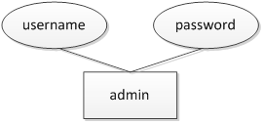

### Table contact



### Table faqs



### Table feedbacks



### Table collections



### Table users



### Table images



### Table comments



### Table user_friends



# Task sheet review 2

|  |  |  |  |  |  |
| --- | --- | --- | --- | --- | --- |
| Project Title: Web Photo Share | | Project Ref. No: 1 | | | |
|  |  | Date of Preparation of Activity Plan | | | |
| No. | Task | Start Date | Actual Days | Member Names | Status |
| 01 | Architecture & Design | September 26, 2013 | 7 | Nguyen Anh Tuan | Completed |
| 02 | Algorithms & Data Flowchart | Nguyen Anh Tuan | Completed |
| 03 | User Case Diagram | Le Ngoc Nhut | Completed |
| 04 | Sequence Diagram | Tran Van Hai | Completed |
| 05 | Entity Relationship Design | Nguyen Vu Hung | Completed |
| 06 | Task sheet | All Members | Completed |

|  |  |  |
| --- | --- | --- |
|  | Prepare By: Group 1 | Approved By: Faculty |
| Date: Oct 02, 2013 | **Team Leader**  **Nguyen Vu Hung** | **Nguyen Ngo Phuoc** |

REVIEW III

# Database Design

## Database Relationship Diagram (DRD)



## Database Structure

### Table: admin

| Field | Type | Null | Key | Default | Extra | Comment |
| --- | --- | --- | --- | --- | --- | --- |
| username | VARCHAR(32) | NO | PK | (NULL) |  |  |
| Password | VARCHAR(32) | NO |  | (NULL) |  |  |

### Table: contact

| Field | Type | Null | Key | Default | Extra | Comment |
| --- | --- | --- | --- | --- | --- | --- |
| contact_id | INT | NO | PK |  | IDENTITY(1,1) |  |
| contact_name | VARCHAR(255) | NO |  |  |  |  |
| contact_email | VARCHAR(255) |  |  |  |  |  |
| contact_subject | VARCHAR(255) |  |  |  |  |  |
| contact_message | TEXT(1000) |  |  |  |  |  |
| contact_reply | TEXT(1000) |  |  |  |  |  |
| contact_status | TINYINT | NO |  | 0 |  | 0: Unread  1: Read  2: Replied |
| contact_date | DATETIME |  |  |  |  |  |
| reply_date | DATETIME |  |  |  |  |  |

### Table: faqs

| Field | Type | Null | Key | Default | Extra | Comment |
| --- | --- | --- | --- | --- | --- | --- |
| faq_id | INT | NO | PK |  | IDENTITY(1,1) |  |
| question | VARCHAR(255) |  |  |  |  |  |
| answer | TEXT(1000) |  |  |  |  |  |

### Table: feedbacks

| Field | Type | Null | Key | Default | Extra | Comment |
| --- | --- | --- | --- | --- | --- | --- |
| feedback_id | INT | NO | PK |  | IDENTITY(1,1) |  |
| user_id | INT | NO | FK |  | users.user_id |  |
| subject | VARCHAR(255) |  |  |  |  |  |
| message | TEXT(1000) |  |  |  |  |  |
| reply | TEXT(1000) |  |  |  |  |  |
| status | TINYINT | NO |  | 0 |  | 0: Unread  1: Read  2: Replied |
| feedback_date | DATETIME |  |  |  |  |  |
| reply_date | DATETIME |  |  |  |  |  |

### Table: collections

| Field | Type | Null | Key | Default | Extra | Comment |
| --- | --- | --- | --- | --- | --- | --- |
| collection_id | INT | NO | PK |  | IDENTITY(1,1) |  |
| title | VARCHAR(255) |  |  |  |  |  |
| status | TINYINT |  |  | 0 |  |  |

### Table: users

| Field | Type | Null | Key | Default | Extra | Comment |
| --- | --- | --- | --- | --- | --- | --- |
| user_id | INT | NO | PK |  | IDENTITY(1,1) |  |
| name | VARCHAR(255) | NO |  |  |  |  |
| username | VARCHAR(32) | NO |  |  | UNIQUE |  |
| password | VARCHAR(32) | NO |  |  |  |  |
| email | VARCHAR(255) | NO |  |  | UNIQUE |  |
| address | VARCHAR(255) | YES |  |  |  |  |
| gender | BIT | NO |  | 0 |  |  |
| birth_year | VARCHAR(4) |  |  |  |  |  |
| user_status | TINYINT | NO |  | 0 |  | 0: Pending  1: Approved  2: Declined |
| reset_password_key | VARCHAR(32) | YES |  |  |  |  |
| join_date | DATETIME |  |  |  |  |  |

### Table: images

| Field | Type | Null | Key | Default | Extra | Comment |
| --- | --- | --- | --- | --- | --- | --- |
| image_id | INT | NO | PK |  | IDENTITY(1,1) |  |
| title | VARCHAR(255) | NO |  |  |  |  |
| user_id | INT | NO | FK |  | users.user_id |  |
| collection_id | INT | NO | FK |  | collection.collection_id |  |
| description | TEXT(1000) |  |  |  |  |  |
| filename | VARCHAR(255) | NO |  |  |  | File name of image |
| path | VARCHAR(255) | NO |  |  |  | Location of image |
| share_status | TINYINT | NO |  |  |  | 0: Private  1: Friend  2: Public |
| upload_date | DATETIME |  |  |  |  |  |
| modify_date | DATETIME |  |  |  |  |  |

### Table: comments

| Field | Type | Null | Key | Default | Extra | Comment |
| --- | --- | --- | --- | --- | --- | --- |
| comment_id | INT | NO | PK |  | IDENTITY(1,1) |  |
| image_id | INT | NO | FK |  | images.image_id |  |
| comment | TEXT(1000) |  |  |  |  |  |
| comment_date | DATETIME |  |  |  |  |  |

### Table user_friends

| Field | Type | Null | Key | Default | Extra | Comment |
| --- | --- | --- | --- | --- | --- | --- |
| friend_id | INT | NO | PK |  | IDENTITY(1,1) |  |
| user_id | INT | NO | FK |  | users.user_id |  |
| friend | INT | NO | FK |  | users.user_id |  |
| request_status | BIT | NO |  | 0 |  | 0: Requested  1: Approved |
| comment_date | DATETIME |  |  |  |  |  |

## Database Constrains

### Table: users

Constraint:

* UNIQUE: username must be unique
* UNIQUE: email must be unique

|  |  |  |  |
| --- | --- | --- | --- |
| Name | Add | Delete | Update |
| users | +  (username)  (email) | - | +  (username)  (email) |

### Table: feedbacks

Constraint:

* FOREIGN KEY: user_id must exist

|  |  |  |  |
| --- | --- | --- | --- |
| Name | Add | Delete | Update |
| feedbacks | +  users.user_id  must exist | - | +  users.user_id  must exist |

### Table: images

Constraint:

* FOREIGN KEY: user_id must exist
* FOREIGN KEY: collection_id must exist

|  |  |  |  |
| --- | --- | --- | --- |
| Name | Add | Delete | Update |
| images | +  users.user_id  must exist  collections.collection_id must exist | - | +  users.user_id  must exist  collections.collection_id  must exist |

### Table: comments

Constraint:

* FOREIGN KEY: image_id must exist

|  |  |  |  |
| --- | --- | --- | --- |
| Name | Add | Delete | Update |
| comments | +  images.image_id  must exist | - | +  images.image_id  must exist |

### Table: user_friends

Constraint:

* FOREIGN KEY: user_id must exist
* FOREIGN KEY: friend must exist

|  |  |  |  |
| --- | --- | --- | --- |
| Name | Add | Delete | Update |
| user_friends | +  users.user_id  must exist  users.user_id  must exist | - | +  users.user_id  must exist  users.user_id  must exist |

# GUI Designs – Front-End

## Homepage

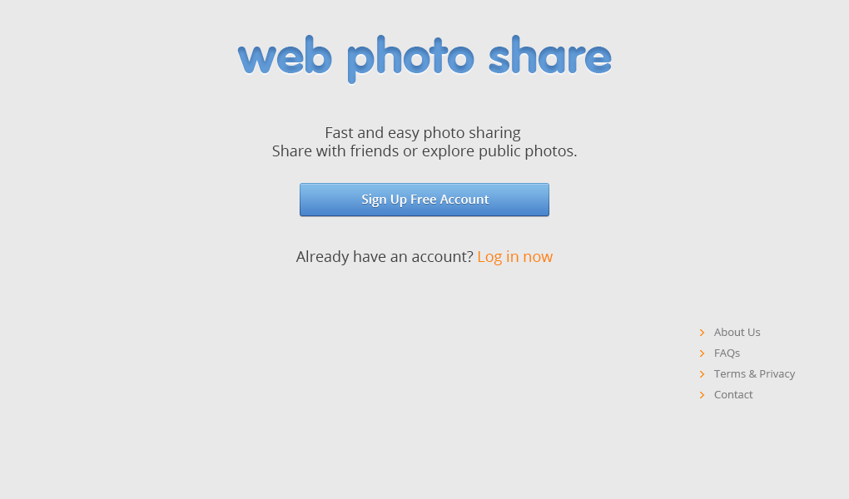

## Login

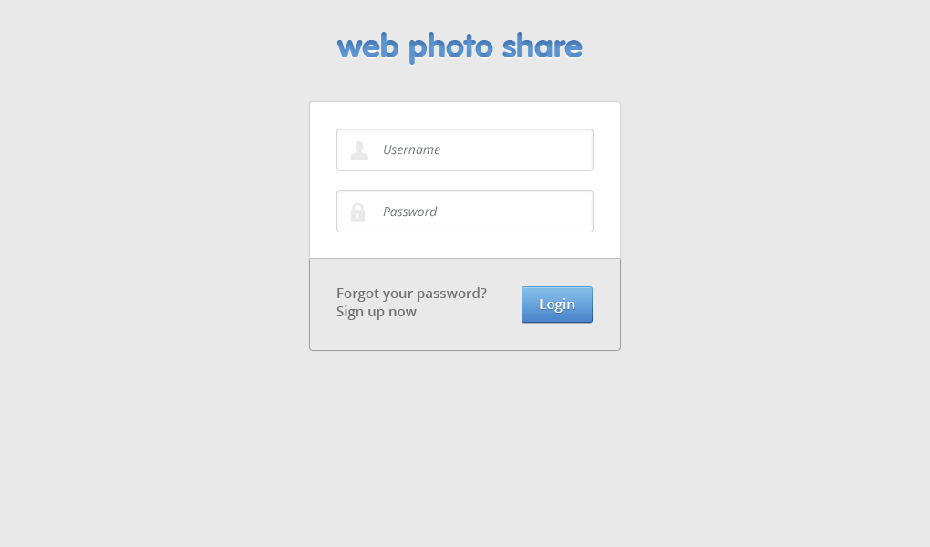

|  |  |  |  |  |  |  |
| --- | --- | --- | --- | --- | --- | --- |
| No. | Name | Type | Validation | Event | Description | Status |
| 1 | txtUsername | Textbox | Not null |  | Username of User | Enable |
| 2 | txtPassword | Textbox (Mode Password) | Not null |  | Password of User | Enable |
| 3 | btnLogin | Button |  | Click | Process Login Request | Enable |

## Sign Up

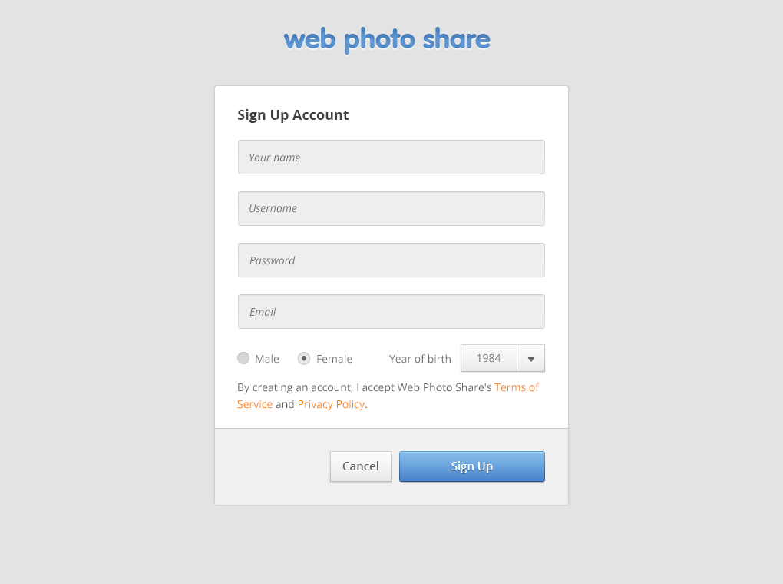

## Homepage

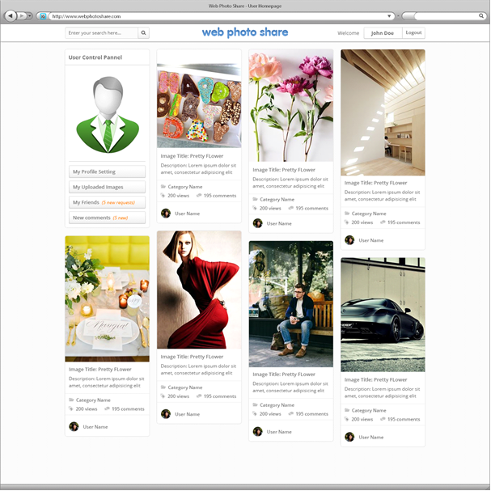

## User Comments

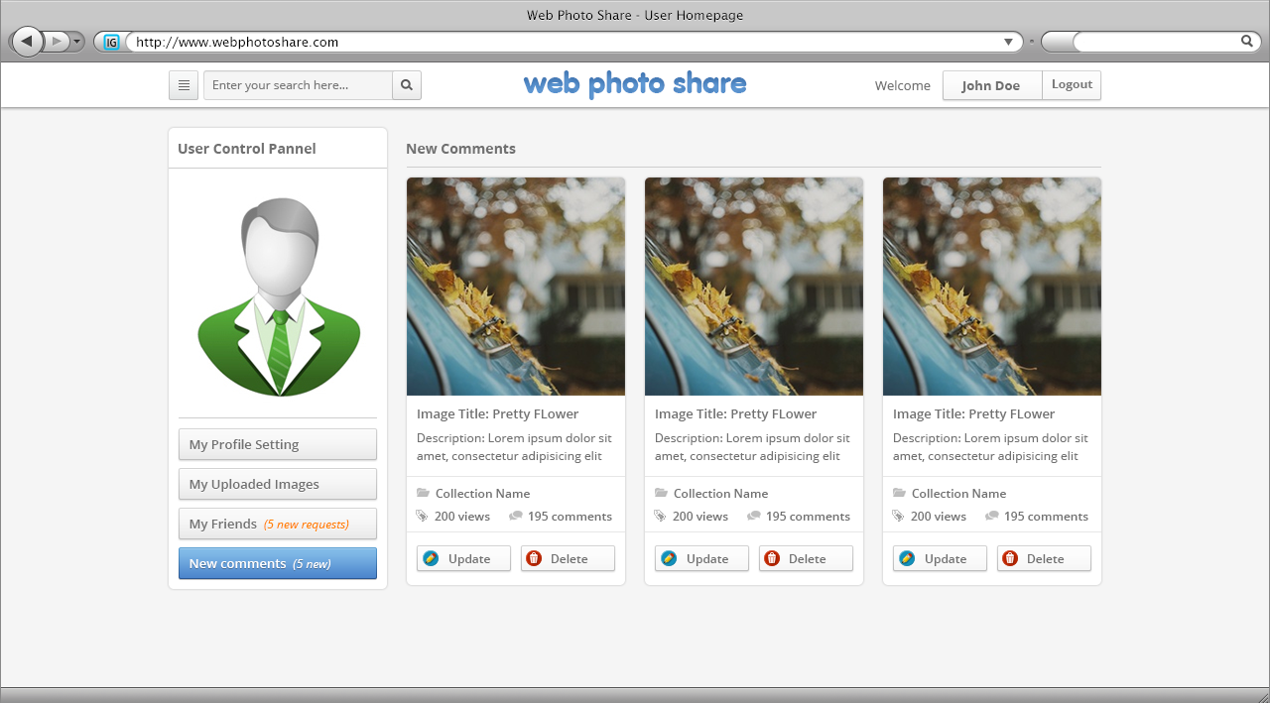

|  |  |  |  |  |  |  |
| --- | --- | --- | --- | --- | --- | --- |
| No. | Name | Type | Validation | Event | Description | Status |
| 1 | btnUpdate | Button |  | Click | Update Image of User | Enable |
| 2 | btnDelete | Button |  | Click | Delete Image of User | Enable |

## User Friends

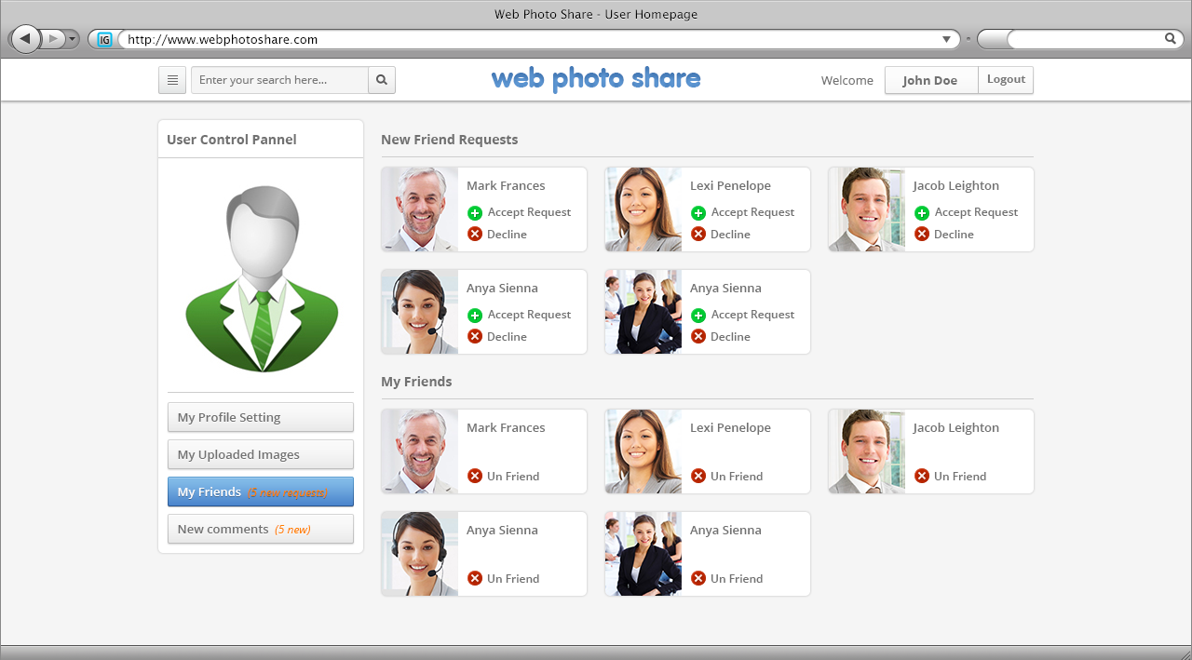

|  |  |  |  |  |  |  |
| --- | --- | --- | --- | --- | --- | --- |
| No. | Name | Type | Validation | Event | Description | Status |
| 1 | btnFriend | Button |  | Click | Add Friends | Enable |
| 2 | btnUnfriend | Button |  | Click | Un Friends | Enable |

## User Profile Change Password

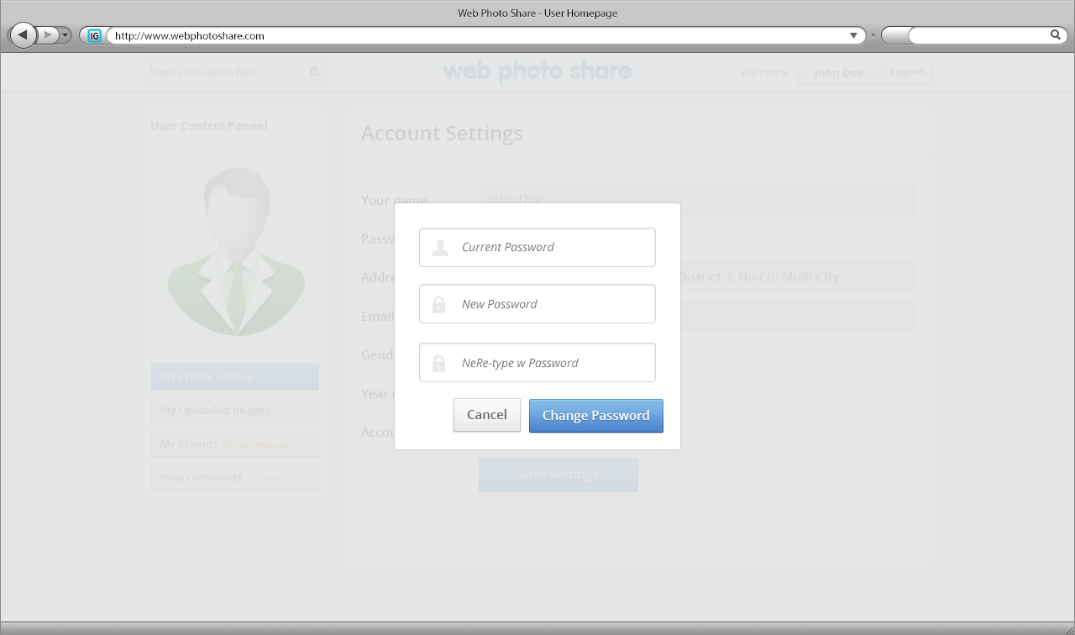

|  |  |  |  |  |  |  |
| --- | --- | --- | --- | --- | --- | --- |
| No. | Name | Type | Validation | Event | Description | Status |
| 1 | txtPassword | Textbox | Not null |  | Password of User | Enable |
| 2 | txtNewpassword | Textbox | Not null |  | New Password | Enable |
| 3 | txtComfim | Textbox | Not null |  | Comfim Password | Enable |
| 4 | btnCancel | Button |  | Click | Return to previous page | Enable |
| 5 | btnChangePassword | Button |  | Click | Request Change Password | Enable |

## User Upload Image

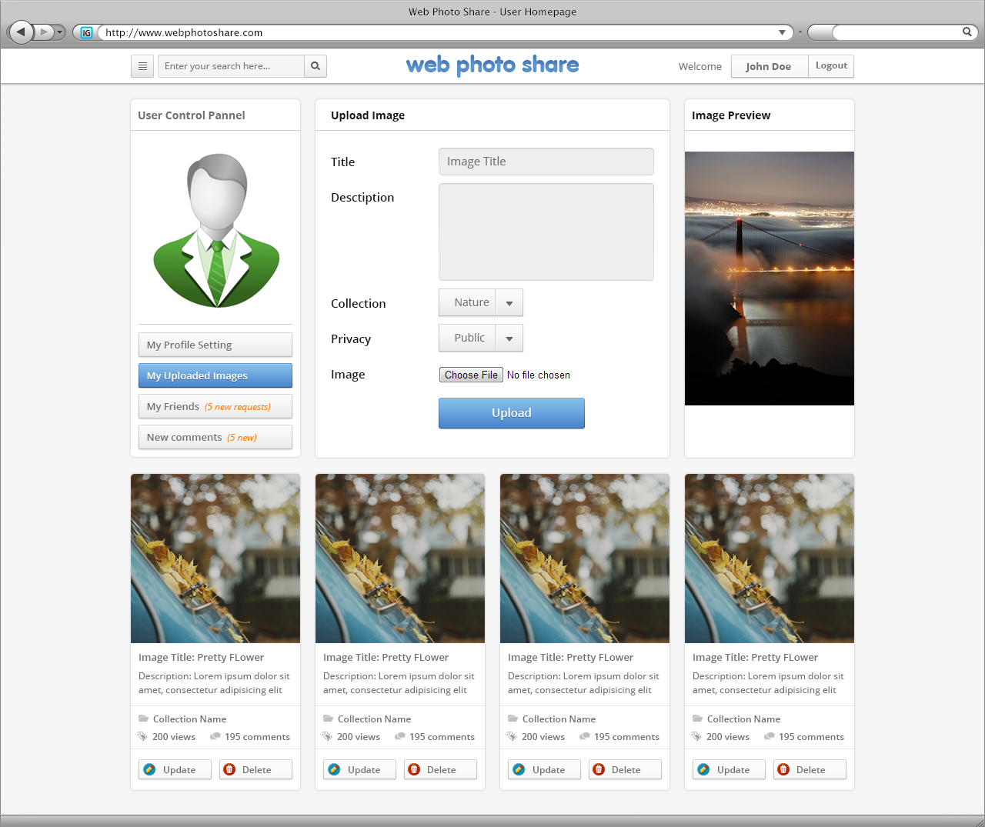

|  |  |  |  |  |  |  |
| --- | --- | --- | --- | --- | --- | --- |
| No. | Name | Type | Validation | Event | Description | Status |
| 1 | txtTitle | Textbox | Not null |  | Title Image | Enable |
| 2 | txtDesctiption | Textbox |  |  | Desctiption of Image | Enable |
| 3 | cboCollection | ComboBox |  |  |  | Enable |
| 4 | cboPrivacy | ComboBox |  |  |  | Enable |
| 5 | fulImage | File Upload |  |  |  | Enable |
| 6 | btnUpload | Button |  | Click | Upload Image | Enable |

## View Image

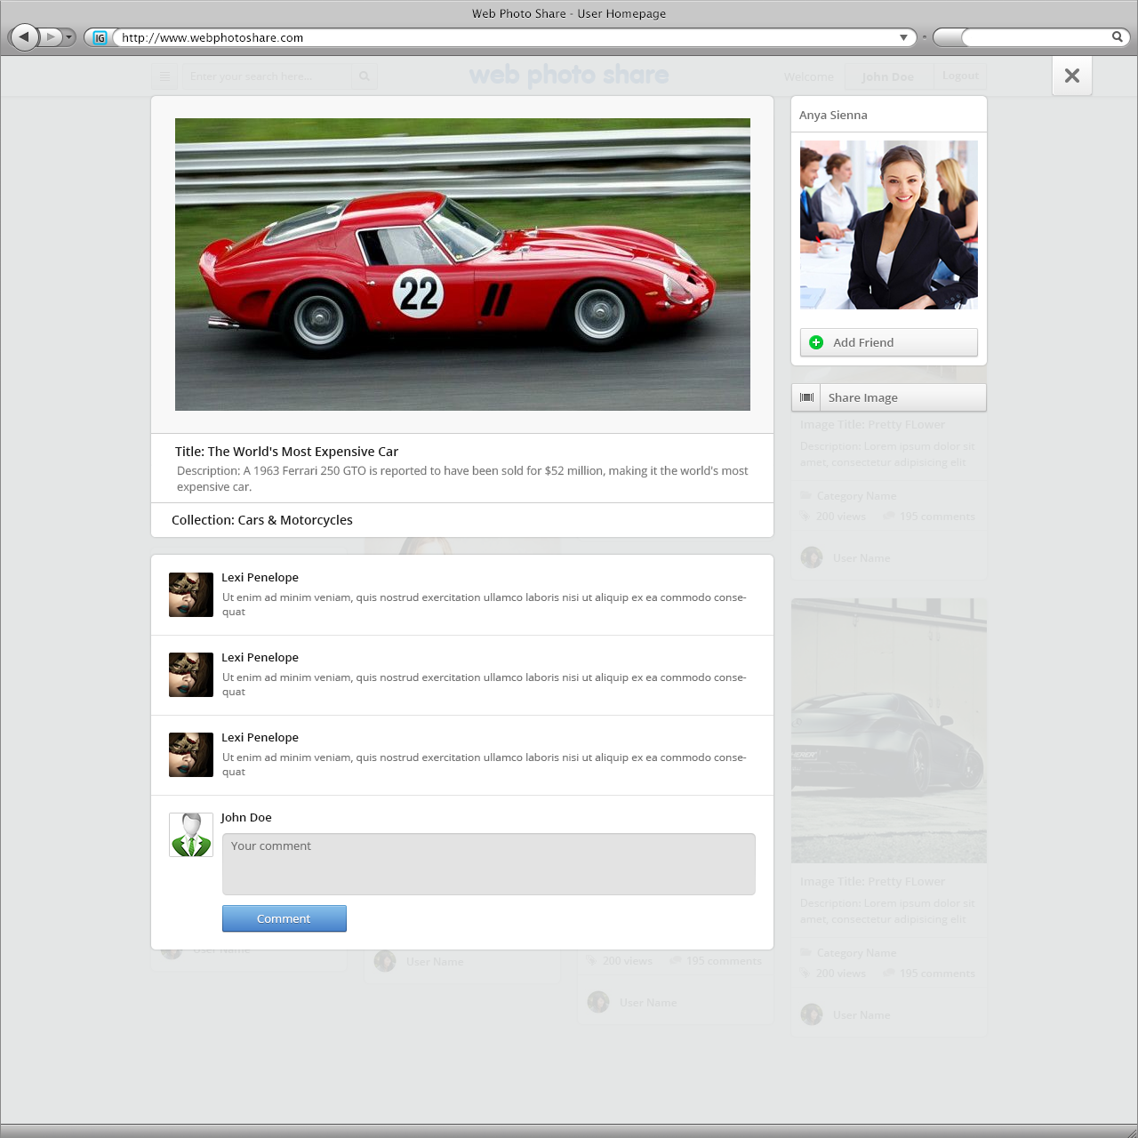

|  |  |  |  |  |  |  |
| --- | --- | --- | --- | --- | --- | --- |
| No. | Name | Type | Validation | Event | Description | Status |
| 1 | txtComment | Textbox | Not null |  | Comment of Igame | Enable |
| 2 | btnComment | Button |  | Click | Requet Comment of Igame | Enable |

## View Menu

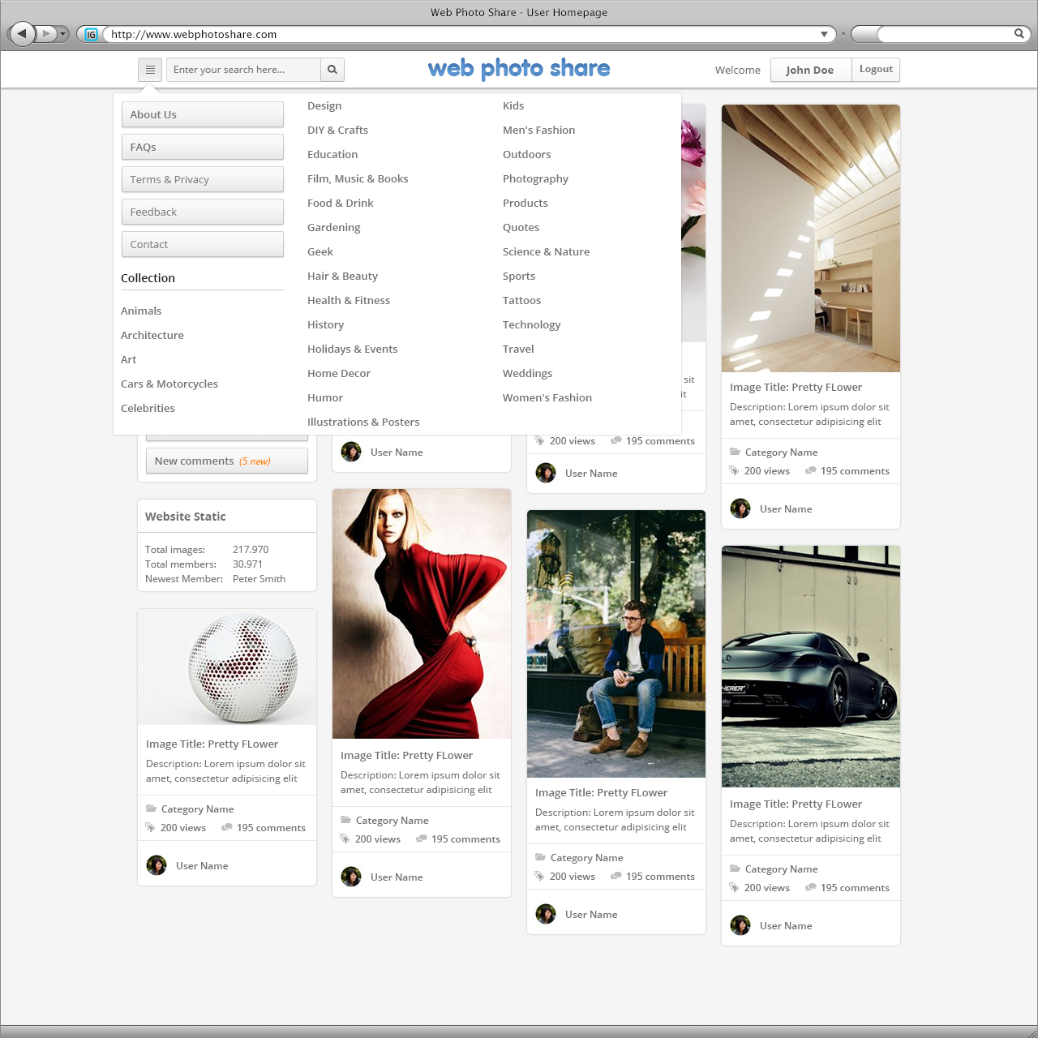

## Page About Us

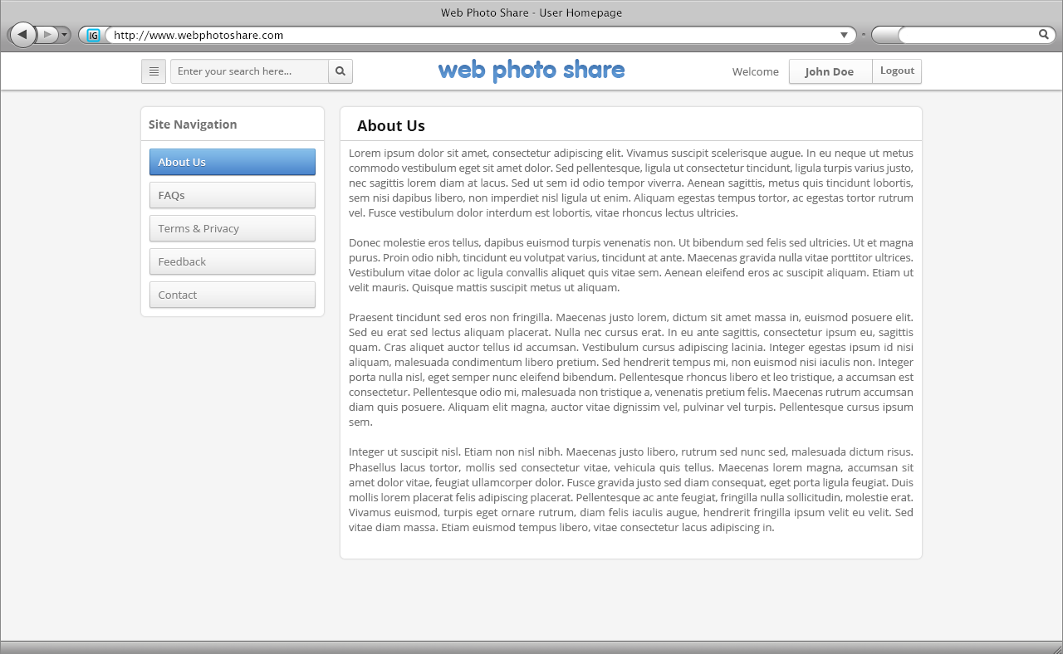

## Page Contact

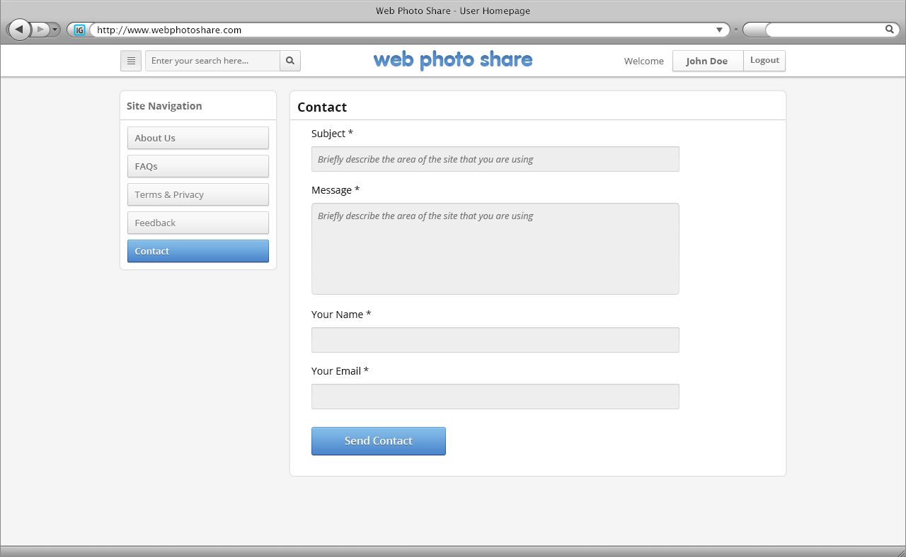

|  |  |  |  |  |  |  |
| --- | --- | --- | --- | --- | --- | --- |
| No. | Name | Type | Validation | Event | Description | Status |
| 1 | txtSubject | Textbox | Not null |  | Subject of Contact | Enable |
| 2 | txtMessage | Textbox | Not null |  | Message of Contact | Enable |
| 3 | txtYourname | Textbox | Not null |  |  | Enable |
| 4 | txtYourEmail | Textbox | Not null |  | Email of User | Enable |
| 5 | btnContact | Button |  | Click | Requet send Contact | Enable |

## Page FAQs

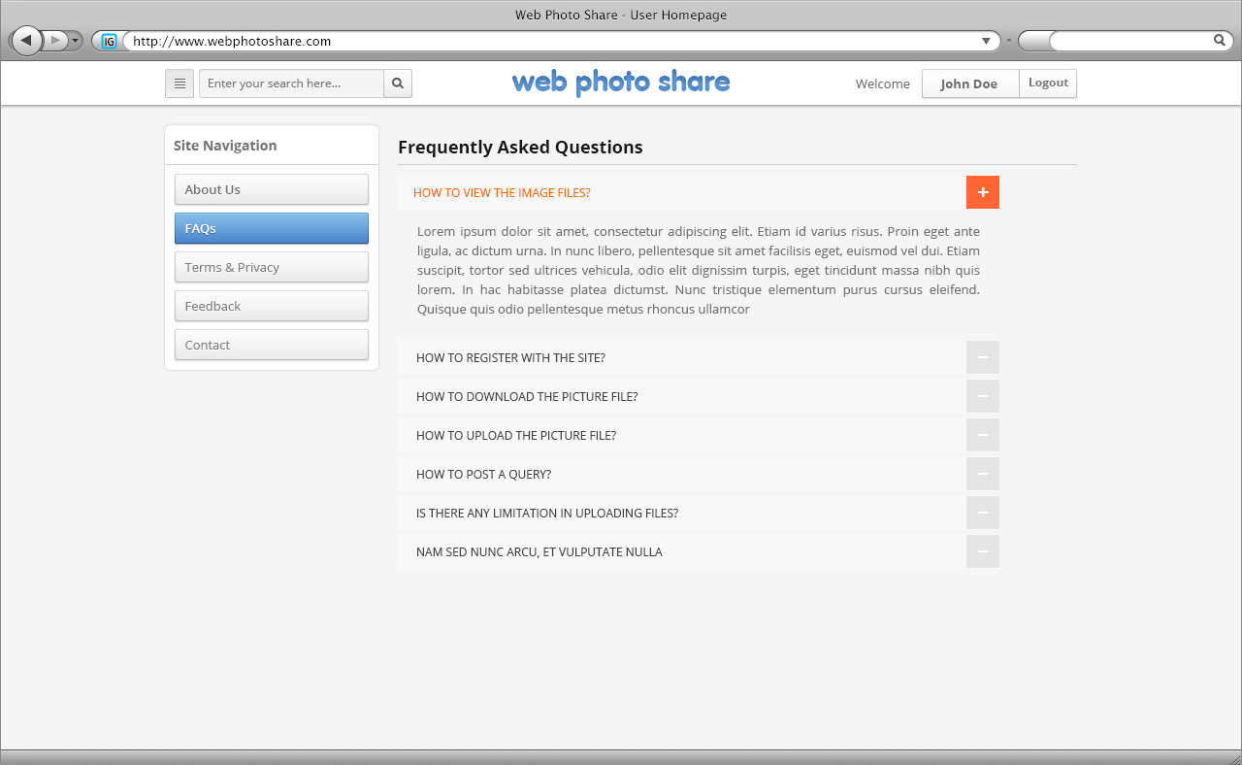

## Page Feedback

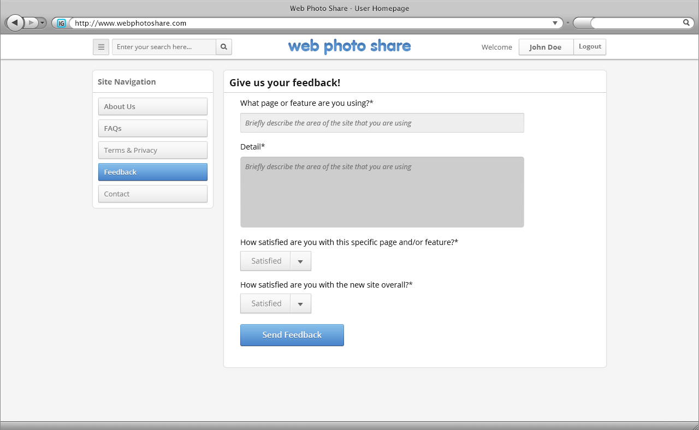

|  |  |  |  |  |  |  |
| --- | --- | --- | --- | --- | --- | --- |
| No. | Name | Type | Validation | Event | Description | Status |
| 1 | txtQuestion | Textbox | Not null |  | Question of FeedBack | Enable |
| 2 | txtAnswer | Textbox | Not null |  | Answer FeedBack | Enable |
| 3 | cboAnswer_1 | ComboBox |  |  |  | Enable |
| 4 | cboAnswer_2 | ComboBox |  |  |  | Enable |
| 5 | btnFeedback | Button |  | Click | Requet send FeedBack | Enable |

## Page Term and Privacy

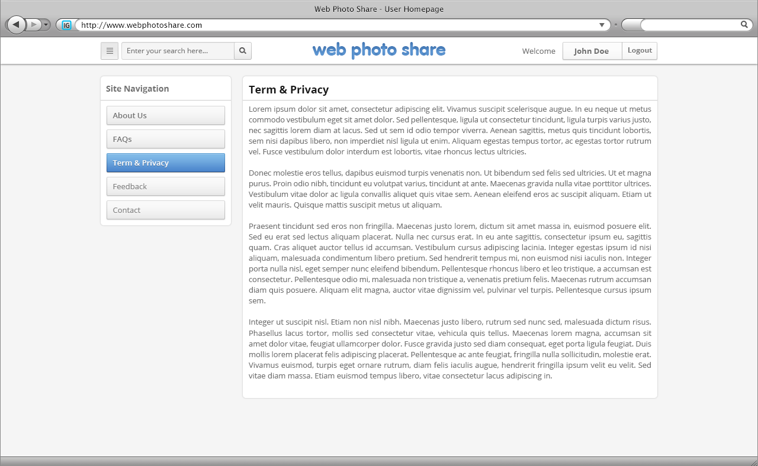

# GUI Design – Back-End

## Login

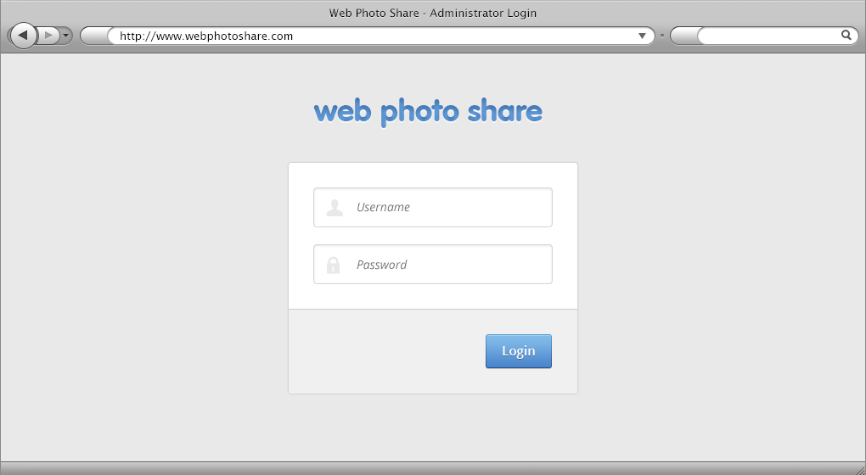

|  |  |  |  |  |  |  |
| --- | --- | --- | --- | --- | --- | --- |
| No. | Name | Type | Validation | Event | Description | Status |
| 1 | txtUsername | Textbox | Not null |  | Username of User | Enable |
| 2 | txtPassword | Textbox (Mode Password) | Not null |  | Password of User | Enable |
| 3 | btnLogin | Button |  | Click | Process Login Request | Enable |

## Administrator Dashboard

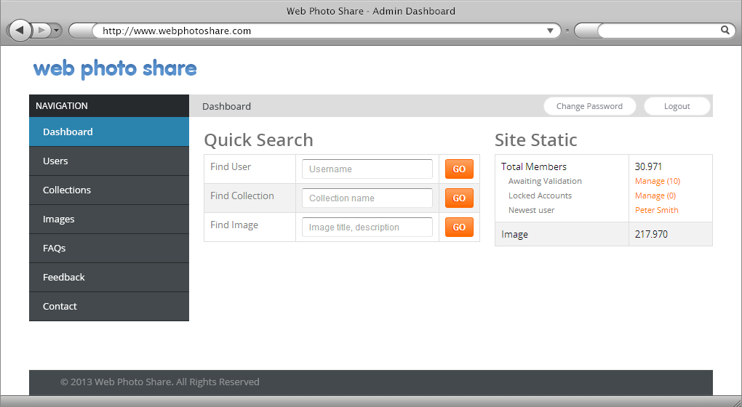

|  |  |  |  |  |  |  |
| --- | --- | --- | --- | --- | --- | --- |
| No. | Name | Type | Validation | Event | Description | Status |
| 1 | txtUsername | Textbox | Not null |  | Username of User | Enable |
| 2 | txtCollectionName | Textbox | Not null |  | Collection Name | Enable |
| 3 | txtImage | Textbox | Not null |  | Image Title ,Description | Enable |
| 4 | btnGo | Button | Click |  | Search | Enable |

## User Manage

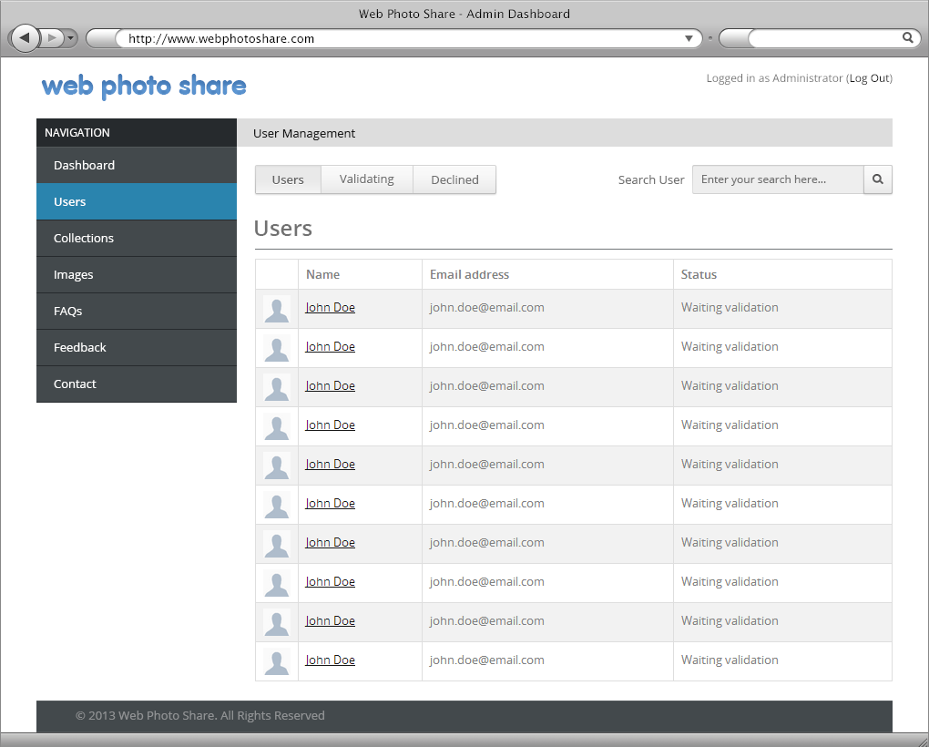

|  |  |  |  |  |  |  |
| --- | --- | --- | --- | --- | --- | --- |
| No. | Name | Type | Validation | Event | Description | Status |
| 1 | txtSearch | Textbox | Not null |  | Search Users | Enable |
| 2 | btnSearch | Button | Not null | Click | Process Search Request | Enable |
| 3 | User,Validating,Declined | Menu |  |  |  | Enable |

## User Manage Declined

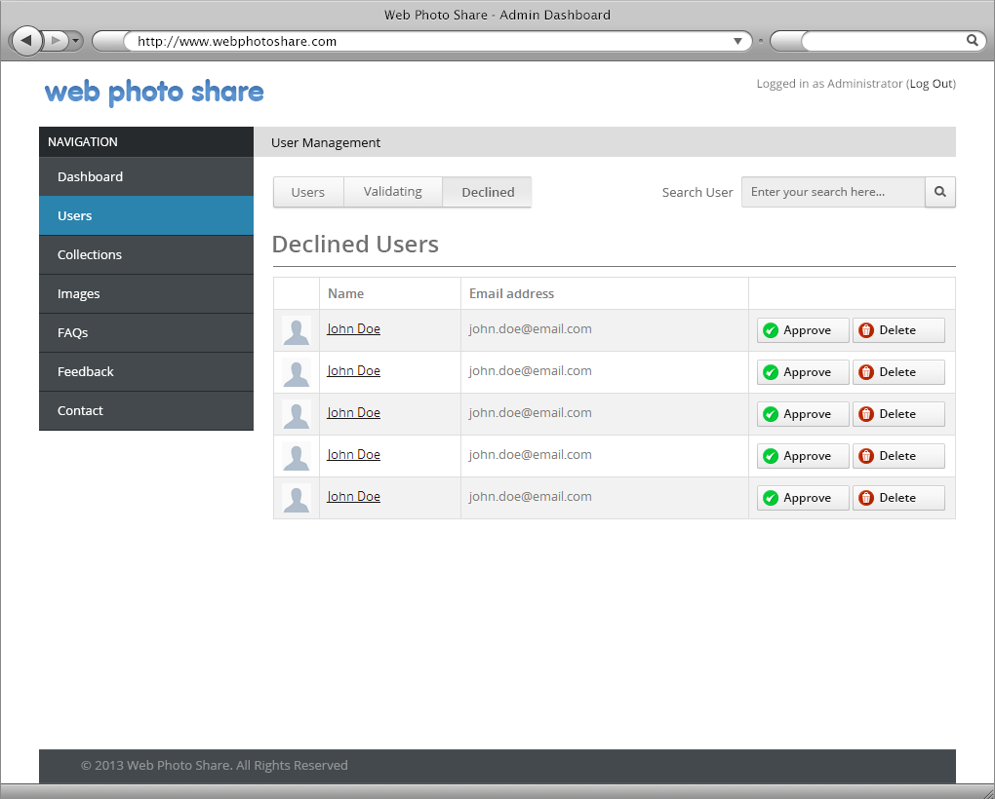

|  |  |  |  |  |  |  |
| --- | --- | --- | --- | --- | --- | --- |
| No. | Name | Type | Validation | Event | Description | Status |
| 1 | txtSearch | Textbox | Not null |  | Search Users | Enable |
| 2 | btnSearch | Button | Not null | Click | Process Search Request | Enable |
| 3 | User,Validating,Declined | Menu |  |  |  | Enable |
| 4 | btnApprove | Button |  | Click | Approve User | Enable |
| 5 | btnDelete | Button |  | Click | Delete User | Enable |

## User Manage Edit User

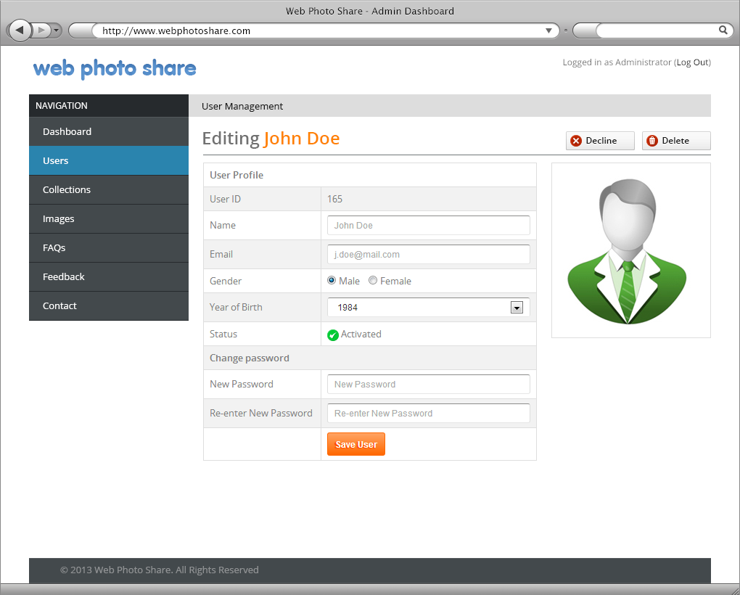

|  |  |  |  |  |  |  |
| --- | --- | --- | --- | --- | --- | --- |
| No. | Name | Type | Validation | Event | Description | Status |
| 1 | txtUserId | Textbox | Not null |  | UserId | Disable |
| 2 | txtUserName | Textbox | Not null |  | UserName | Enable |
| 3 | txtEmail | Textbox | Not null |  | Email | Enable |
| 4 | radGender | RadioButton |  | Click | Gender(Male,Female) | Enable |
| 5 | cboYearOfBirth | Combobox | Not null |  | Year Of Birth | Enable |
| 6 | txtNewPassword | Textbox |  |  | New Password | Enable |
| 7 | txtReNewPassword | Textbox |  |  | Re-Enter New Password | Enable |
| 8 | btnSave | Button |  | Click | Save User Edit | Enable |
| 9 | btnDecline | Button |  | Click | Decline User | Enable |
| 1o | btnDelete | Button |  | Click | Delete User | Enable |

## User Manage Validating

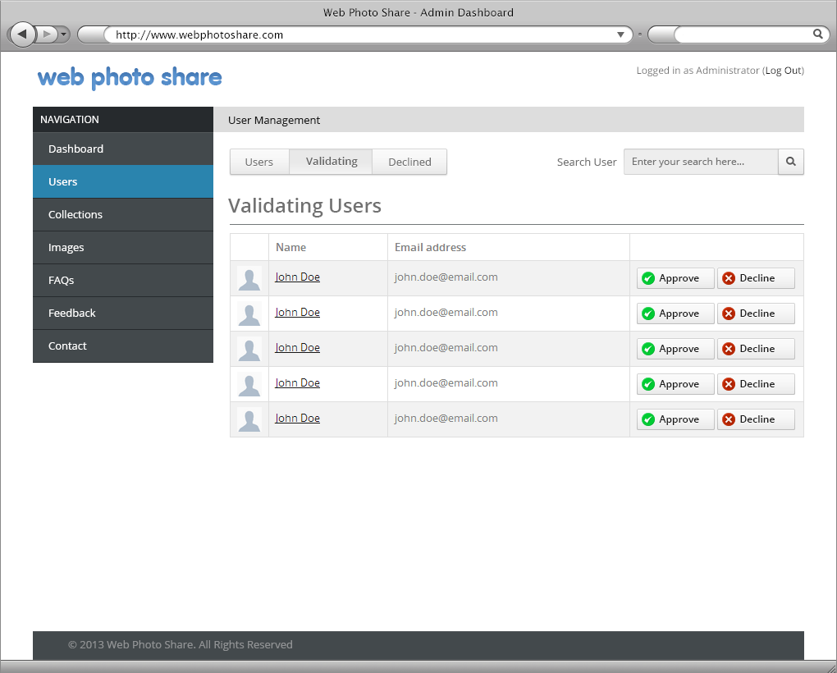

|  |  |  |  |  |  |  |
| --- | --- | --- | --- | --- | --- | --- |
| No. | Name | Type | Validation | Event | Description | Status |
| 1 | txtSearch | Textbox | Not null |  | Search Users | Enable |
| 2 | btnSearch | Button | Not null | Click | Process Search Request | Enable |
| 3 | User,Validating,Declined | Menu |  |  |  | Enable |
| 4 | btnApprove | Button |  | Click | Approve User | Enable |
| 5 | btnDelete | Button |  | Click | Delete User | Enable |

## Collection Manage

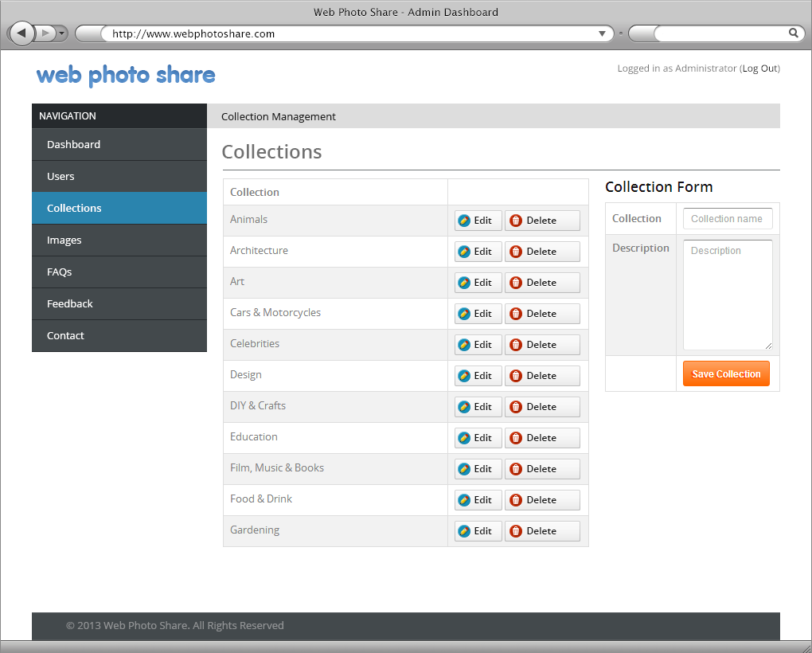

|  |  |  |  |  |  |  |
| --- | --- | --- | --- | --- | --- | --- |
| No. | Name | Type | Validation | Event | Description | Status |
| 1 | btnEdit | Button |  | Click | Edit Question | Enable |
| 2 | btnDelete | Button |  | Click | Delete Question | Enable |
| 3 | txtCollection | Textbox | Not Null |  | Collection Name | Enable |
| 4 | txtDescrption | Textbox | Not Null |  | Description | Enable |
| 5 | btnSave | Button |  | Click | Save Collection | Enable |

## Image Manage

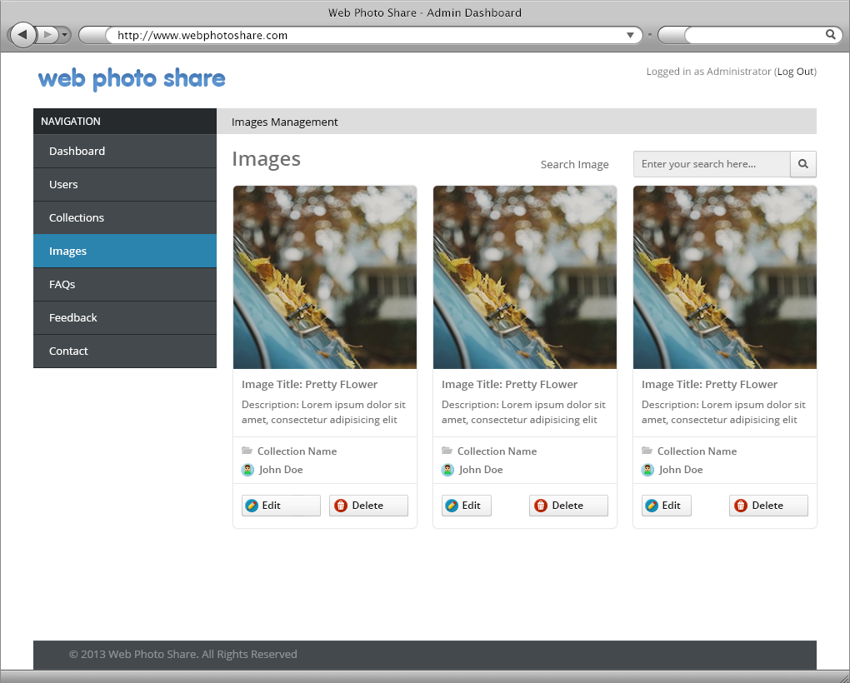

|  |  |  |  |  |  |  |
| --- | --- | --- | --- | --- | --- | --- |
| No. | Name | Type | Validation | Event | Description | Status |
| 1 | txtSearch | Textbox | Not Null |  | Search Image | Enable |
| 2 | btnSearch | Button |  | Click | Start Search | Enable |
| 3 | btnEdit | Button |  | Click | Edit Image Detail | Enable |
| 4 | btnDelete | Button |  | Click | Delete Image | Enable |
| 5 | btnSearch | Button |  | Click | Search Image | Enable |
| 6 | txtSearch | Textbox |  |  | Search Image | Enable |

## Image Manage Edit

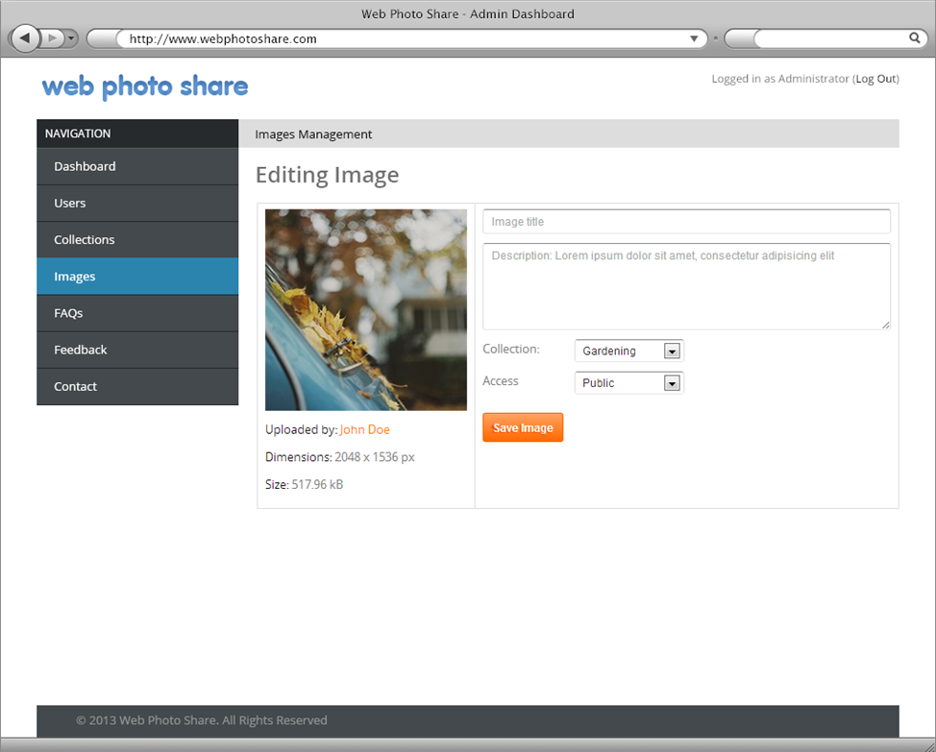

|  |  |  |  |  |  |  |
| --- | --- | --- | --- | --- | --- | --- |
| No. | Name | Type | Validation | Event | Description | Status |
| 1 | txtTitle | Textbox | Not Null |  | Title of Image | Enable |
| 2 | txtDescription | Textbox | Not Null |  | Depscription of Image | Enable |
| 3 | cboCollection | Combobox | Not Null |  | Collection Name | Enable |
| 4 | cboAccess | Combobox | Not Null |  | Status Image | Enable |
| 5 | btnSave | Button |  | Click | Save Image | Enable |

## FAQs Manage

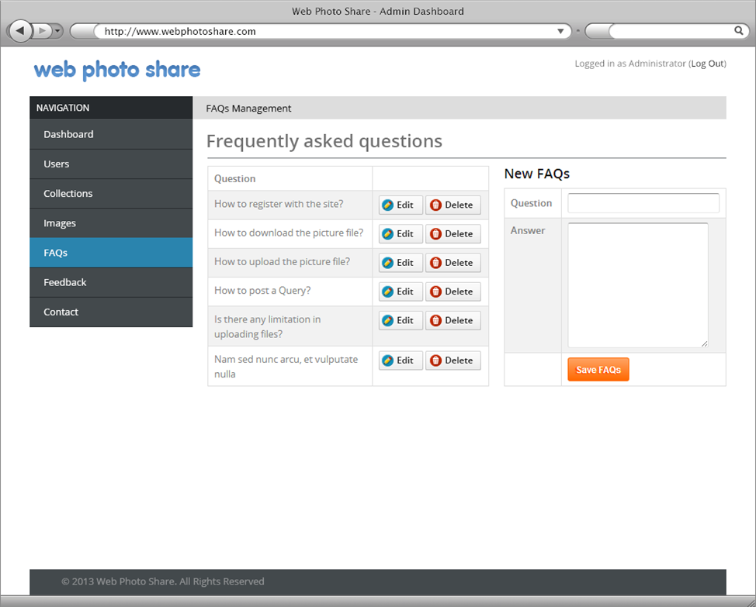

|  |  |  |  |  |  |  |
| --- | --- | --- | --- | --- | --- | --- |
| No. | Name | Type | Validation | Event | Description | Status |
| 1 | btnEdit | Button |  | Click | Edit Question | Enable |
| 2 | btnDelete | Button |  | Click | Delete Question | Enable |
| 3 | txtQuestion | Textbox | Not Null |  | Question | Enable |
| 4 | txtAnswer | Textbox | Not Null |  | Answer | Enable |
| 5 | btnSave | Button |  | Click | Save FAQs | Enable |

## Contact Manage

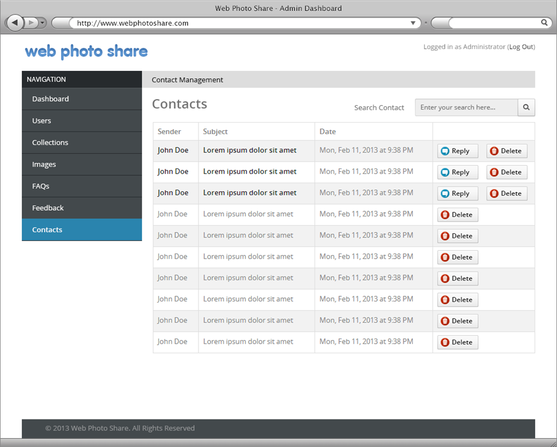

|  |  |  |  |  |  |  |
| --- | --- | --- | --- | --- | --- | --- |
| No. | Name | Type | Validation | Event | Description | Status |
| 1 | btnDelete | Button |  | Click | Delete Contact | Enable |
| 2 | btnReply | Button |  | Click | Content Reply | Enable |
| 3 | btnSearch | Button |  | Click | Search Contacts | Enable |
| 4 | txtSearch | Textbox |  |  | Search Contacts | Enable |

## Contact Manage Reply

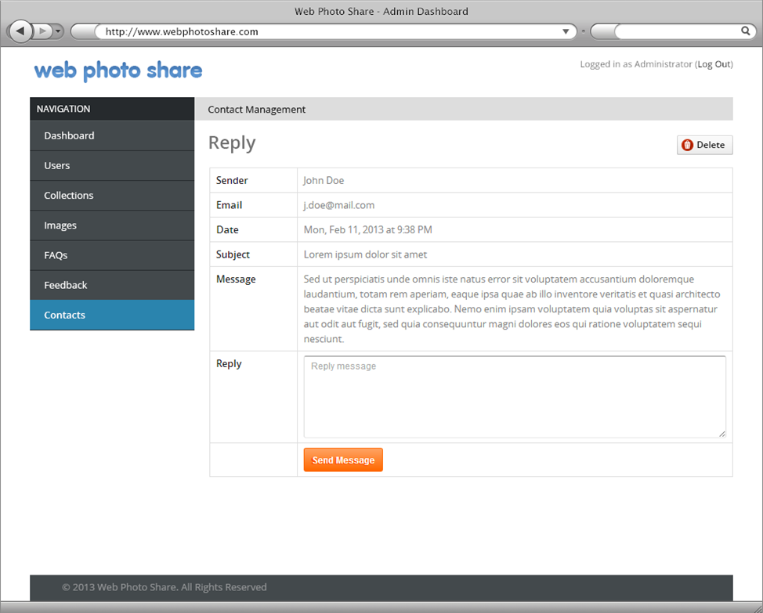

|  |  |  |  |  |  |  |
| --- | --- | --- | --- | --- | --- | --- |
| No. | Name | Type | Validation | Event | Description | Status |
| 1 | btnDelete | Button |  | Click | Delete Contact | Enable |
| 2 | txtReply | Textbox | Not null |  | Content Reply | Enable |
| 3 | btnSend | Button |  | Click | Process Send Reply | Enable |

# Sitemap

## Front-End Sitemap



## Back-End Sitemap



# Task sheet review 3

|  |  |  |  |  |  |
| --- | --- | --- | --- | --- | --- |
| Project Title: Web Photo Share | | Project Ref. No: 2 | | | |
|  |  | Date of Preparation of Activity Plan | | | |
| No. | Task | Start Date | Actual Days | Member Names | Status |
| 01 | Database Relationship | 03 October, 2013 | 10 | Le Ngoc Nhut  Nguyen Van Hai | Completed |
| 02 | Database Structure | Le Ngoc Nhut | Completed |
| 03 | Database Constrains | Nguyen Van Hai | Completed |
| 04 | GUI Design Front-End | Nguyen Vu Hung | Completed |
| 05 | GUI Design Back-End | Nguyen Vu Hung | Completed |
| 06 | Site Map | Nguyen Anh Tuan | Completed |

|  |  |  |
| --- | --- | --- |
|  | Prepare By: Group 1 | Approved By: Faculty |
| Date: Oct 12, 2013 | **Team Leader**  **Nguyen Vu Hung** | **Nguyen Ngo Phuoc** |